Google Analytics Account Creation:

Google Analytics is a free tool provided by Google. We can track the audience what they watch, spend time with our blog, what they like, what are all the action they taken inside our domain like add to cart, purchase, forms submit.

To create an Account and integrate with shopify app:

Account Creation:
Open the Google analytics page and started to create an account
Account Details:

Account Name:
Maari’s Daily Market

Select all the data sharing options.

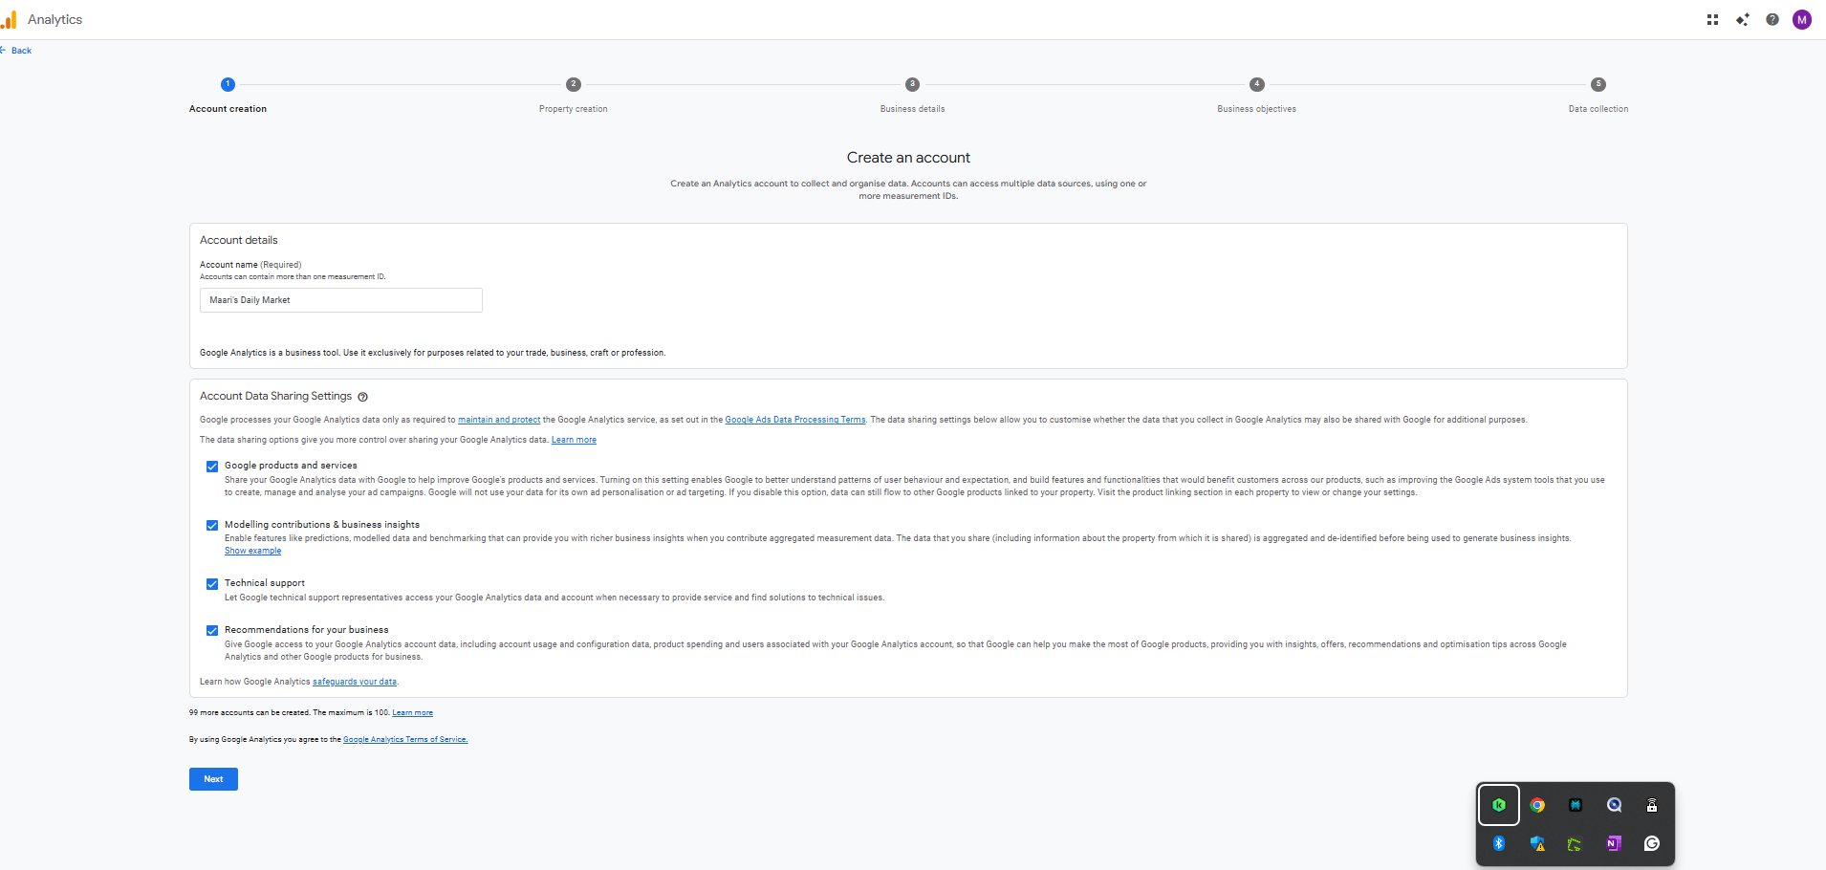
Property Creation:

Property Details:
Property Name: The Daily Market T-Nagar
Reporting Time Zone: Wherever we have a
shop time zone
Currency: The chosen country's currency

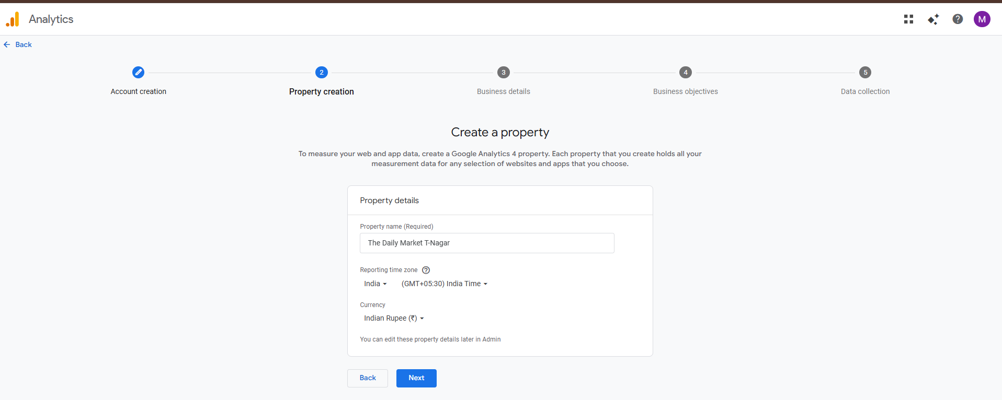

Business Details:
Select the business category, and select the business activity.

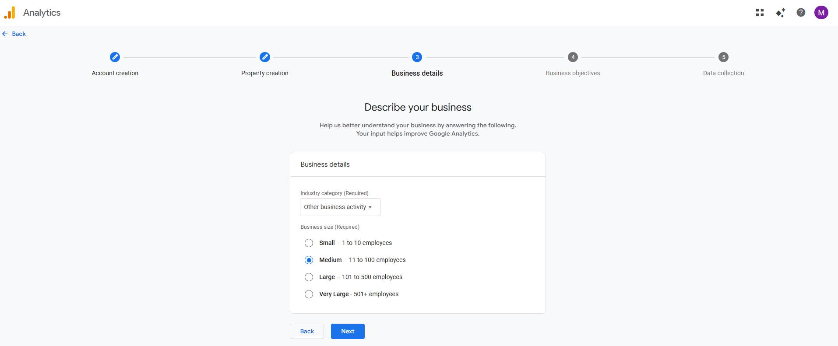

Business Objectives:
For business point of view we can select all the objective that will help to growth our business.
Generate Leads
Drive Sales
Understand web and/or app traffic
View user engagement and retention

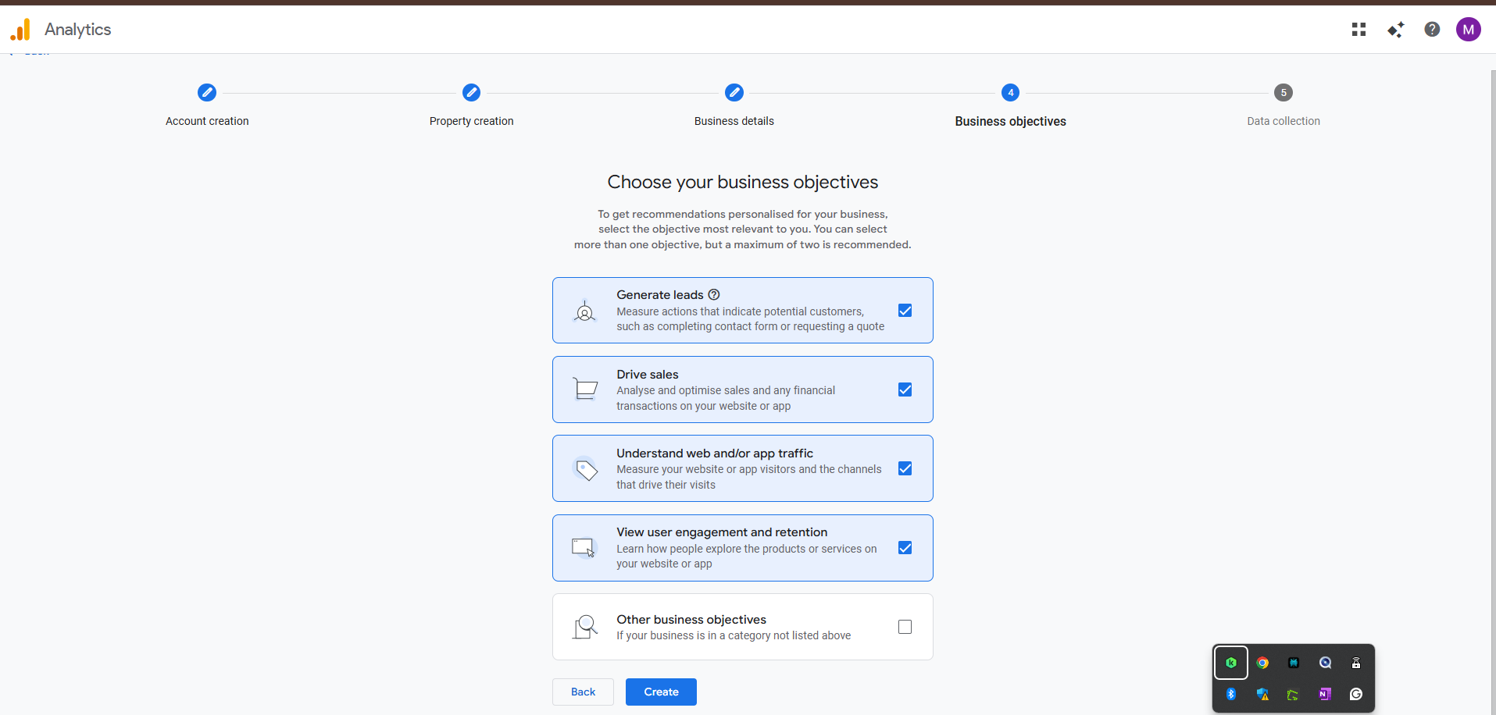

Then choose platform web/app(android)/app(iphone)
Select data stream
Put our website URL:
https://bpucwg-gp.myshopify.com/

Stream Name:
The Daily Market - T.Nagar

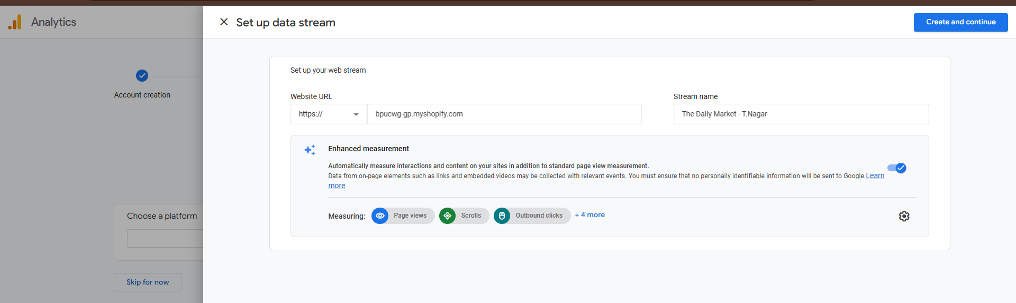

Once we create and continue:

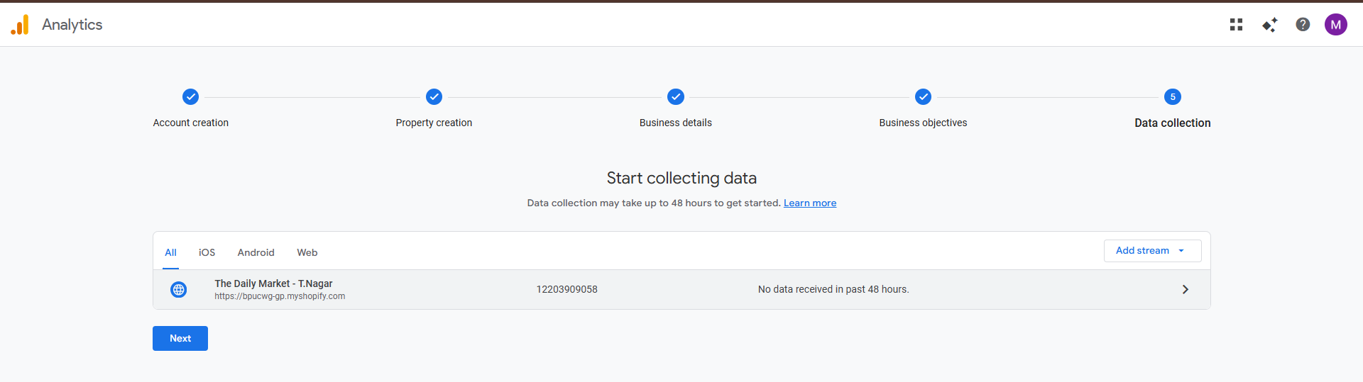

In shopify:

in apps module:
Install the Google & Youtube app and integrate with our site

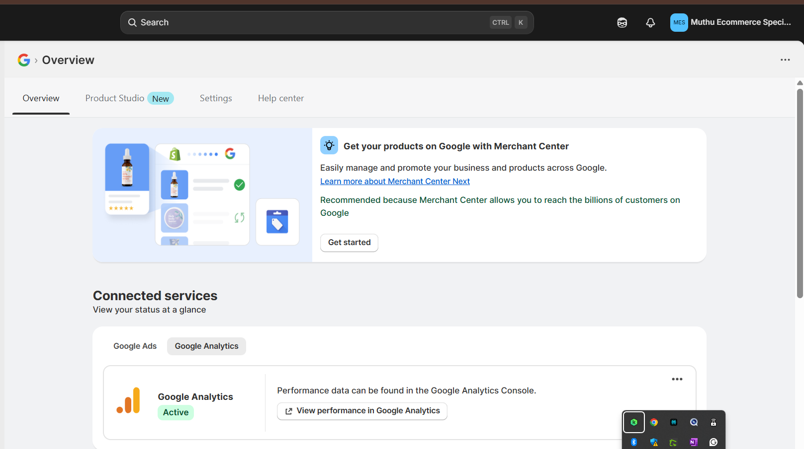

Click view performance in google analytics

Then it will show our site analytics
